TC-CUS-003
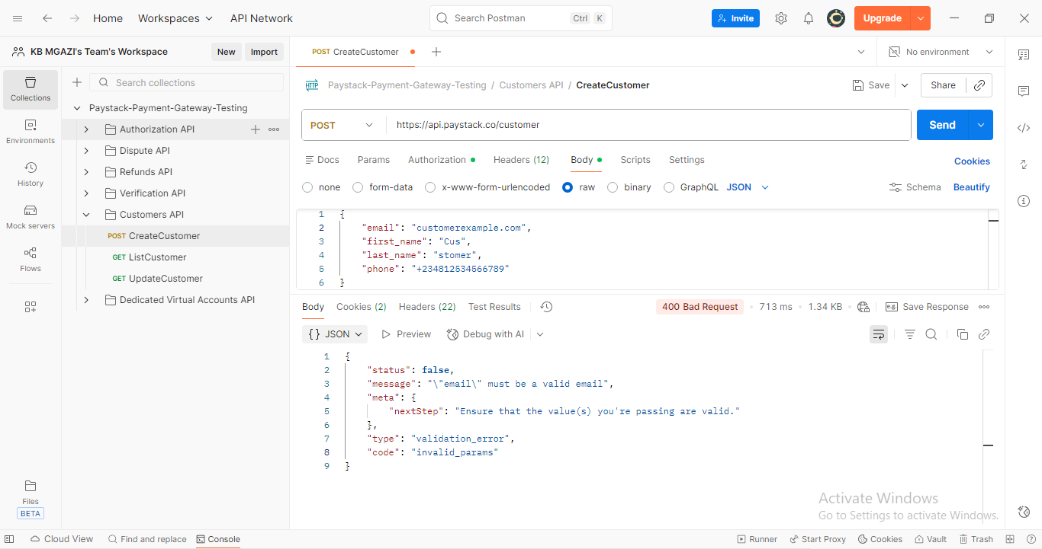
Request:
{
"email": "customerexample.com",
"first_name": "Cus",
"last_name": "stomer",
"phone": "+234812534566789"
}

Response:
{
"status": false,
"message": "\"email\" must be a valid email",
"meta": {
"nextStep": "Ensure that the value(s) you're passing are valid."
},
"type": "validation_error",
"code": "invalid_params"
}

